Project Design Phase
Solution Architecture

Date | 30 September 2026
Team ID | SWTID-2026-2617
Project Name | Streamlining IT Procurement: Automating Standard Laptop Orders with Flow Designer
Team Size | 4
Team Leader | Goushikram G
Team Members | Santhosh Karthick A  Jason Selvin Raj J  Abutharick M
Maximum Marks | 4 Marks

Solution Architecture:
Solution architecture is a complex process – with many sub-processes – that bridges the gap between business problems and technology solutions. Its goals are to:
- Find the best tech solution to solve existing business problems.
- Describe the structure, characteristics, behavior, and other aspects of the software to project stakeholders.
- Define features, development phases, and solution requirements.
- Provide specifications according to which the solution is defined, managed, and delivered.

Solution Architecture Diagram:

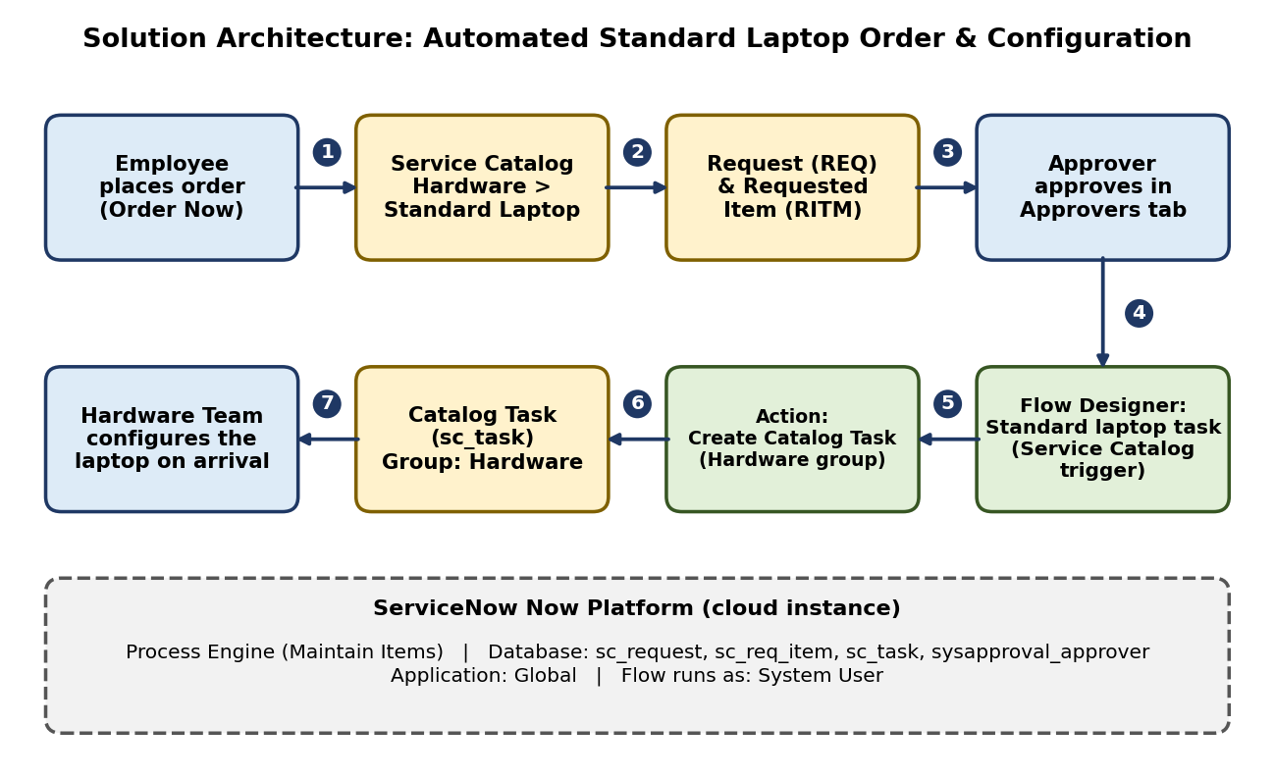
Figure 1: Architecture and data flow of the automated standard laptop order and configuration solution (ServiceNow Flow Designer)

How the solution works:
1. The employee opens Service Catalog > Hardware > Standard Laptop and places the order with Order Now.
2. ServiceNow creates the Request (REQ) and Requested Item (RITM). The Standard Laptop item has the flow attached under Process Engine.
3. The approver opens the Approvers section of the request and approves it.
4. The Service Catalog trigger starts the flow "Standard laptop task" (Application: Global, Run as: System User).
5. The Create Catalog Task action creates the task with short description "Laptop needs to Configured", Assignment group Hardware and Approval Approved.
6. The catalog task is saved (sc_task) and shown under Catalog Tasks on the Requested Item.
7. The Hardware team picks up the task and configures the laptop when it arrives.

Reference video: https://youtu.be/3nsUWtzpDz4

